Product Main Parameter/Function

Camera | Description
Chip | CV1821
Sensor | SC3336(Short focal lens), GC2063(Telephoto lens)
Resolution | 2304×1296(Short focal lens), 1920×1080(Telephoto lens)
Diagonal angle of view | 110°(Short focal lens), 45°(Telephoto lens)
Lens focal length | 3.6mm/8mm
Night vision function | Infrared night vision / Color night vision
Audio and video | Description
Video coding protocol | H.264/H.265
Video code rate | 80Kbps~800Kbps (self-adaption)
Audio compression method | G.711A/AAC
Major function | Description
3D digital noise reduction | Support
Wide dynamic | Support
Backlight compensation | Support
White balance | Support
IR-CUT | Support
POE power supply | Support
Human shape detection | Support
Motion detection | Support
Voice detection | Support
Motion Tracking | Support
Network | Description
Network Protocol | L2TP, IPv4, IGMP, ICMP, ARP, TCP, UDP, DHCP,RTP,RTSP, RTCP,UPnP, DNS,PPPoE,DDNS,NTP, FTP,HTTP, HTTPS,SIP, 802.1x
Interface | Description
Audio input and output | Audio wiring, 1 wires input, 1 wires output
Power | DC 12V⎓1A,PoE 48V⎓0.3A
Button | Reset button
Network interface | RJ45 10M/100M  2.4G WIFI
Storage | Description
Local storage | Micro SD, support a maximum of 128GB
Operation | Description
Working environment | -20℃ to +60℃

CV1821+SC3336/GC2063 Wiring diagram
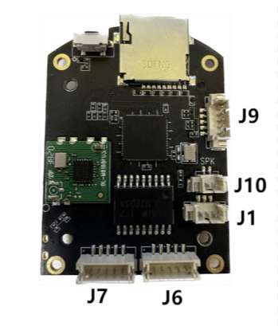
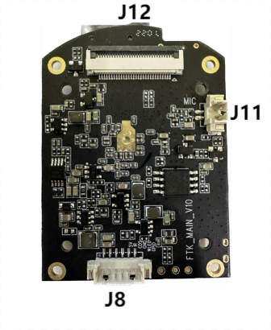
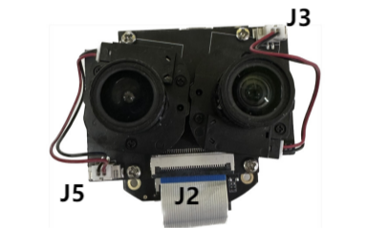

Interface | Description
J9 | 1:TXP 2:TXN 3:RXP 4:RXN 5:PHY_LED
J10 | 1:SPK- 2:SPK+
J1 | 1:KEY 2:GND 3:12V_IN
J6 | 1:MT_5V 2:MA4 3:MA3 4:MA2 5:MA1
J7 | 1:MT_5V 2:MB4 3:MB3 4:MB2 5:MB1
J11 | 1:MIC_IN 2:GND
J8 | 1:PIR 2:WLED 3:GND 4:CDS 5:IRLED 6:5V_IN
J12 | 1、2、3:SPI_VCC 4、6、8、13、16、19、22、25、28:GND 5:CAM_MCLK1 7:CAM_MCLK2 9:I2C2_SCL 10:I2C2_SDA 11:RST1 12:RST2 14:CKP 15CKN 17:DOP 18:DON 20:D1P 21:DIN 23:CKP 24:CKN 26:D0P 27:D0N 29:IR_CUT_EN_SC 30:IR_CUT_EN_GC
J3 | 1:IR_OUTA1 2:IR_OUTB1
J5 | 1:IR_OUTA2 2:IR_OUTB2
J2 | 1、2、3:SPI_VCC 4、6、8、13、16、19、22、25、28:GND 5:CAM_MCLK1 7:CAM_MCLK2 9:I2C2_SCL 10:I2C2_SDA 11:RST1 12:RST2 14:CKP 15CKN 17:DOP 18:DON 20:D1P 21:DIN 23:CKP 24:CKN 26:D0P 27:D0N 29:IR_CUT_EN_SC 30:IR_CUT_EN_GC

